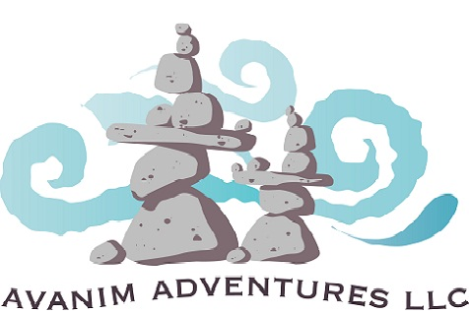

Activity Profile
Colorado Adventure 2023
The purpose of this document is to outline the profile of the physical activity you will be doing on this trip so you and your medical provider can decide if this is the right wilderness experience for you. In order to maximize your enjoyment, your safety and comfort must take precedence. Please review the following and discuss with your medical provider:
This trip takes place in the backcountry. The official definition of backcountry is more than one hour away from comprehensive medical care. On this trip we will be a number of hours away from comprehensive medical care. If you are generally healthy or you have well-managed medical conditions this is generally not an issue. However, if you have any acute medical conditions or you are at acute risk of medical conditions that may require comprehensive care please speak to Ari Hoffman, Avanim Adventures Head Guide, before booking your trip.
The primary physical activities on the Colorado Adventure 2023 are backpacking and kayaking.
The kayaking involves upper body strength and repeated shoulder and elbow movement.
The hiking involves lower body strength and repeated movement of your trunk and legs. You will also be expected to carry an internal frame hiking backpack weighing up to around 50 lbs and you will carry this pack for up to 7 miles per day. Included in carrying a backpack is being able to pick it up and put it on. Most of the time you will have assistance in donning and doffing your pack but it’s important that you be able to do so alone as well.
While there is no technical (ropes) climbing planned for this trip we may encounter areas where we scramble which is using hands and feet to climb up or down a steep area.
The hiking will ascend and descend steep grades.
Inherent in a multi-day wilderness trip is sleeping in a sleeping bag on the ground with a sleeping pad.
On this trip we will spend prolonged periods of time at or above 10,000 feet above sea level. If you live at sea level we advise that you arrive in Denver a couple days ahead of time to assist your acclimation. There is no clear understanding of who is at more or less risk of acute mountain sickness (also called altitude sickness) and it usually consists of nausea and general malaise without any long-term ill effects. If you have consistently uncomfortable reactions to being at altitude please let us know.

If you have any questions or concerns about the activities involved in this trip please contact head guide, Ari Hoffman at 303-803-4832 or avanimadventures@gmail.com

